**DAY 4 CHEAT SHEET**

API Status Codes

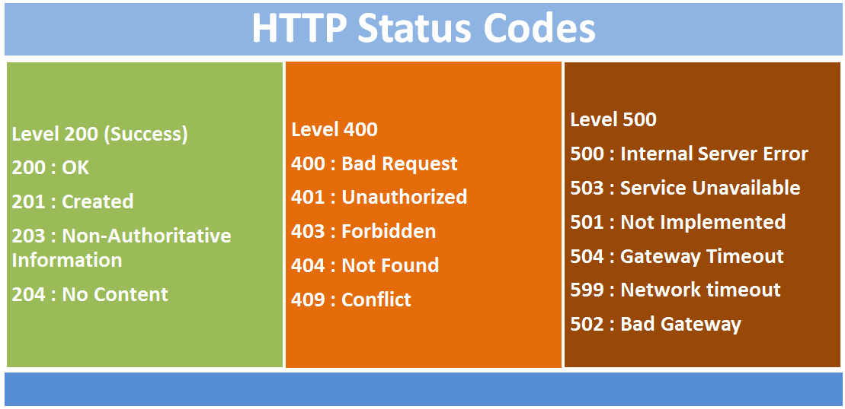

Reverse Geo JSON Response

